After reviewing the website in multiple views, I found some things that need to be addressed. The image below shows the view from a Moto G4 mobile device. The navigation banner needs to be adequately adjusted to fit this screen size, the images need to be resized to fit this screen size, and the text needs to look better too.

**First issue** – the logo and other images looked a little messy when viewed on different screens. 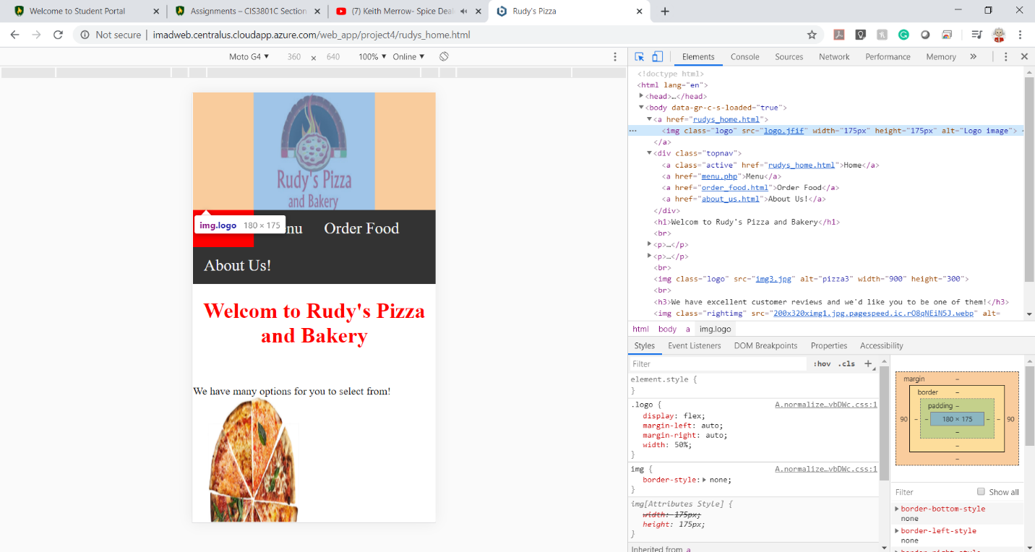

The issue was solved by removing the previous sizes and placing **( <img src="img_girl.jpg" style="max-width:100%;height:auto;"> )** instead. As we can see, the logo and the images look more friendly.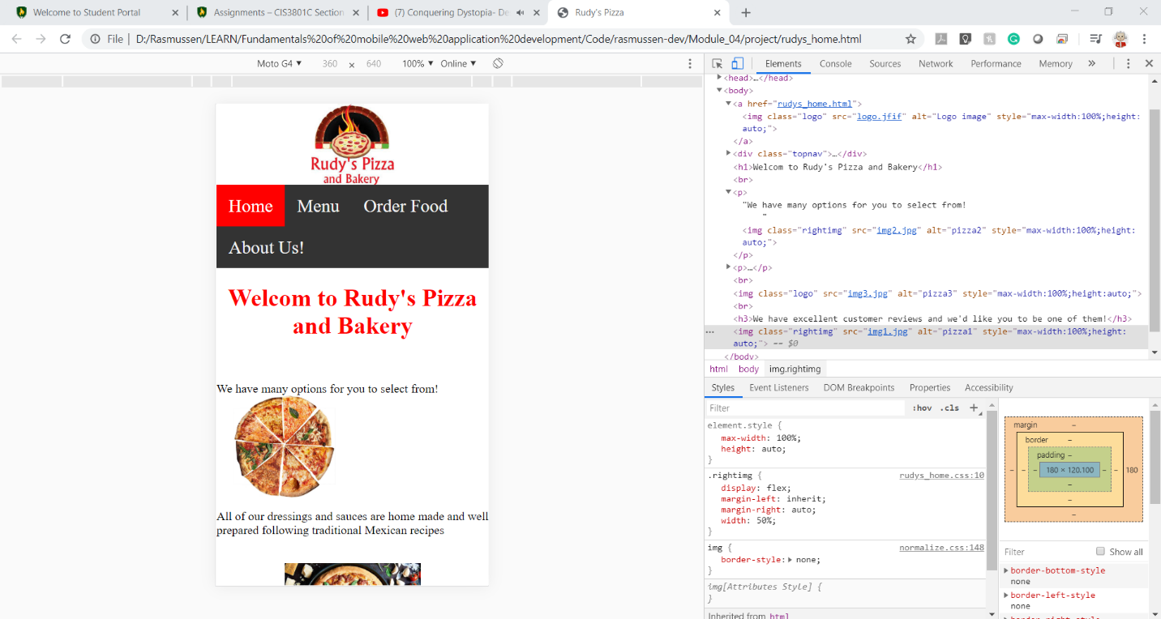

**Second issue** – The navigation banner looked a little oversized when viewed in smaller screen sizes 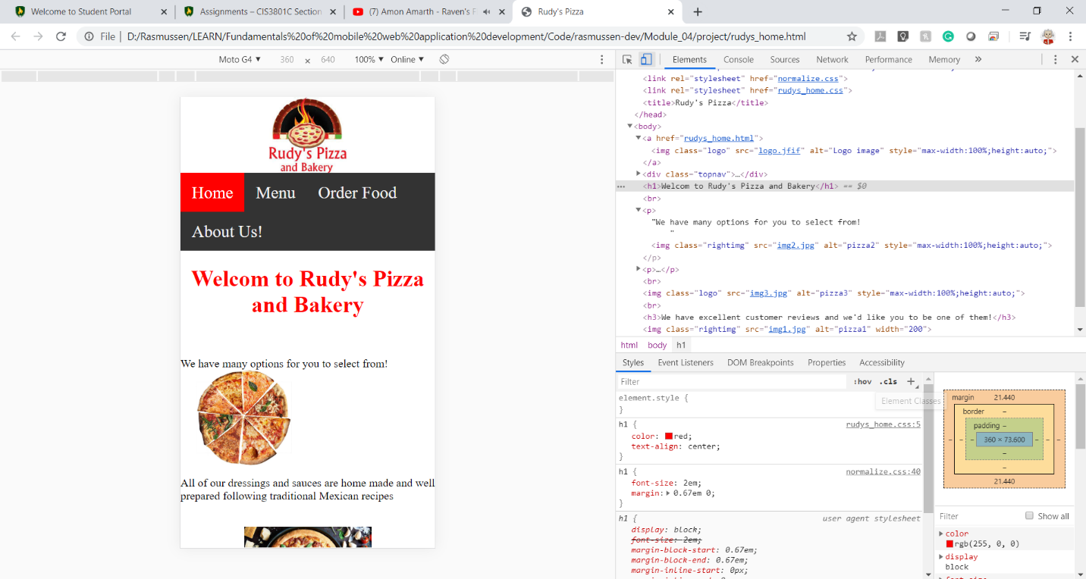

This issue was addressed by using the bootstrap CSS file and using the class “container” for the div ‘s used for this banner. The banner is now more centered and looks better than before.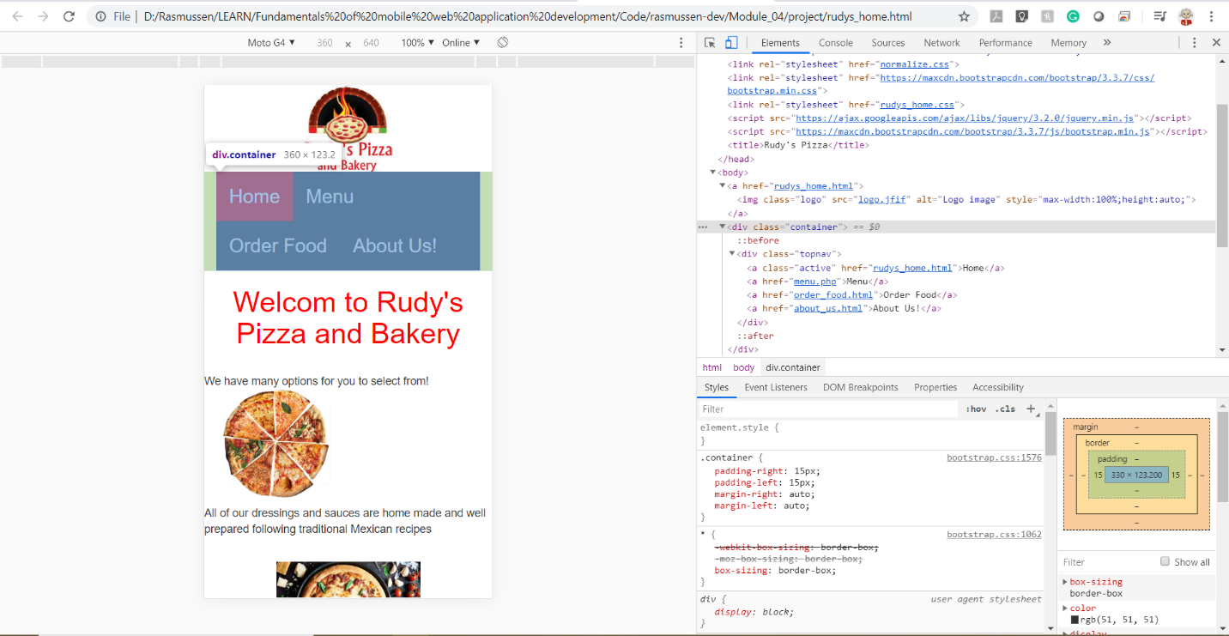

**The third issue** – the text in the image was not responsive when viewed in different screen sizes, and this makes it so hard to read the text in smaller screens.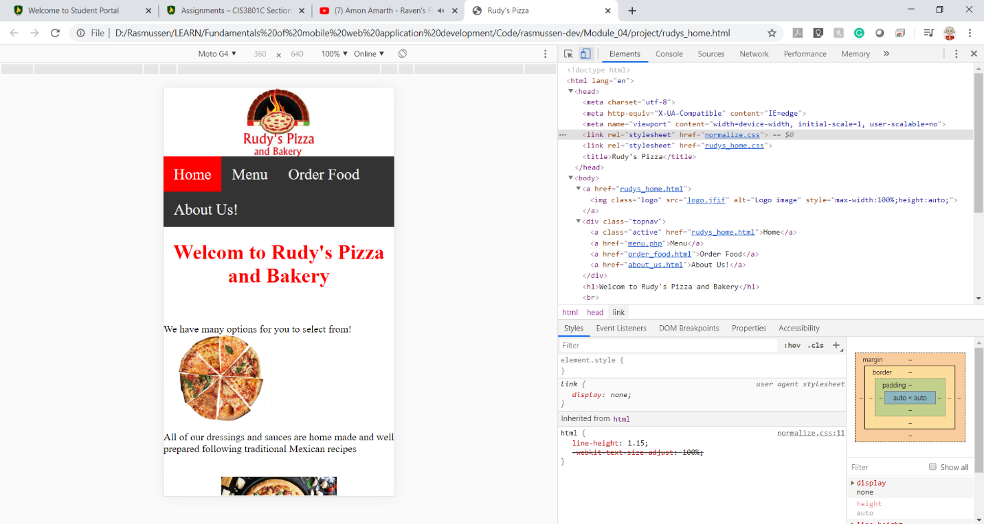

Also, after using bootstrap CSS, the text looks more welcoming and pleasing to the eyes. 